Project RStudio Server

1. Connect to FDU VPN.
2. Login to RStudtio Server by navigating to <http://132.238.7.193:8787/> and entering user ID and password you used for Ambari.
3. In the RStudio Server execute the same code, which you ran in the Project RStudio on your personal computer (see Project RStudio).
   * Remember, that you need to identify the file as described in Step 7 of Project RStudio.
4. You cannot open a file from your personal computer in RStudio Server. This is what you can do:
   * Create a new RMarkdown in RStudio Server

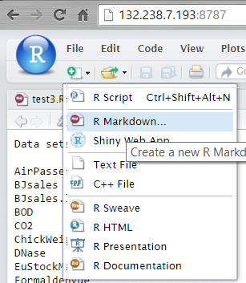

* + Now you have a blank RMarkdown document.
  + Open the script you need to run using RStudio on your personal computer.
  + Select the contents of the script from your computer and paste it in the blank RMarkdown script you created in the RStudio Server.
  + Knit HTML (or PDF).
  + Note. You might need to install missing packages as you did for RStudio on your personal computer.